

Soft Drinks, Water and flatware available, BYOB
Raffle Ticket on Sale for all Prizes 100THB or 6 for 500THB

OPEN TO VFW MEMBERS YOUR FAMILY AND INVITED GUESTS. HOPE YOU CAN JOIN US
Date: Saturday, 04 July 2026
TIME: 1000 – ??00 HRS.

LOCATION: SOOKASAM - 3

GPS: 17° 22’ 03.76” N 102° 52’ 41.40” E

POT LUCK: Please Bring a Dish to Share

VFW Post 10249
Independence Day Celebration


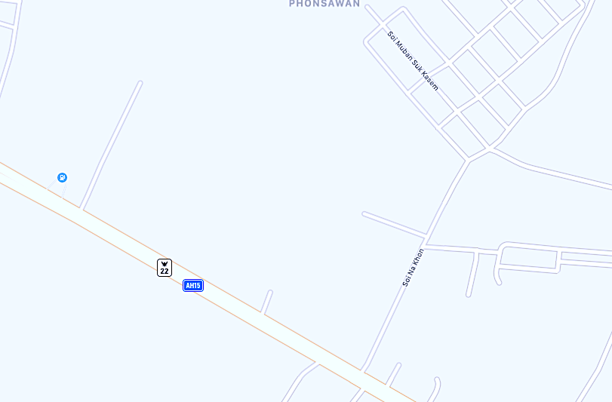
From the overpass by BIG-C travel @ 6.5km
turn left on Soi Na Khon, then turn left at the village sign then take the 1st right.
You will see the tents!
< Udon– Nong Han >
Soi Na Khon
Sookasam Village 1, 3

